# Week 4: Advanced Machine Learning Concepts and Model Evaluation

As our exploration deepens into the realm of Machine Learning (ML), Week 4 unfolds with a focus on advanced concepts, intricate evaluation metrics, and techniques crucial for enhancing the robustness of ML models. This week marks a pivotal juncture where theoretical understanding converges with practical methodologies, equipping learners with the tools to navigate complex scenarios and elevate their mastery of the ML landscape.

Evaluating Model Performance: A Comprehensive Exploration of Metrics in Machine Learning

As we delve into the multifaceted world of machine learning (ML), the assessment of model performance emerges as a critical aspect, shaping the effectiveness and reliability of algorithms across diverse tasks. In this comprehensive exploration, we navigate through the intricacies of evaluation metrics, unraveling their significance in the context of regression, classification, and clustering.

### Regression Metrics

**Mean Absolute Error (MAE)**, a foundational metric, quantifies the average absolute differences between predicted and actual values. This metric provides a straightforward measure of how far, on average, the model's predictions deviate from the true values.

**Mean Squared Error (MSE)** takes a more stringent approach by computing the average squared differences between predicted and actual values. This metric penalizes larger errors more significantly than MAE, offering a nuanced perspective on the model's performance.

**R-squared**, an additional metric, evaluates the proportion of the variance in the dependent variable that can be predicted from the independent variables. A higher R-squared value signifies a better fit of the model to the data.

These regression metrics collectively offer a comprehensive view of how well a model captures the underlying patterns in continuous data. They provide practitioners with tools to assess the accuracy and precision of predictions, crucial in domains such as finance, healthcare, and environmental science.

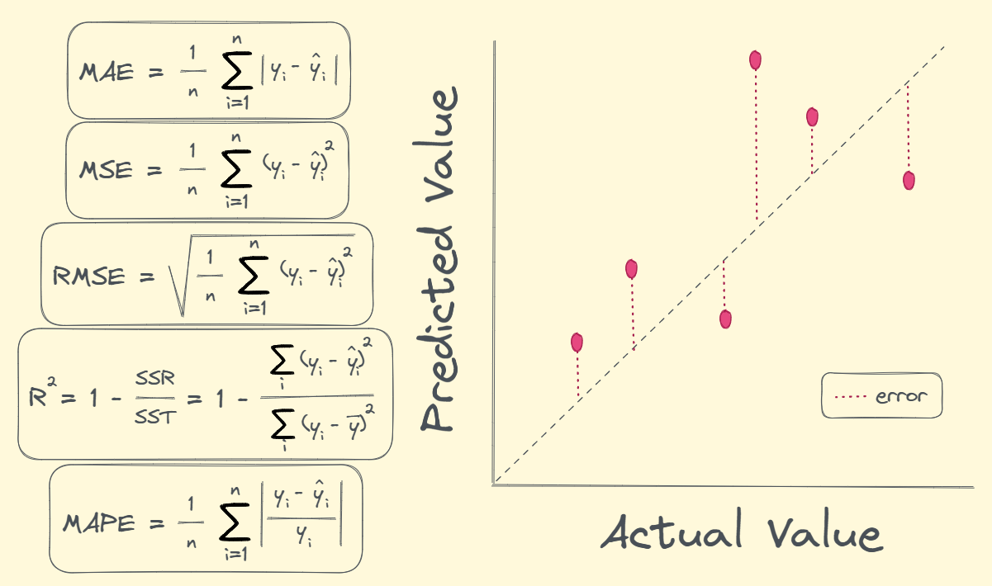

Detailed analysis and explanation of regression metrics: <https://machinelearningmastery.com/regression-metrics-for-machine-learning/>

R squared: <https://corporatefinanceinstitute.com/resources/data-science/r-squared/>

### Classification Metrics

**Accuracy**, the simplest metric, measures the overall correctness of predictions, providing a high-level view of the model's performance.

**Precision** delves into the ratio of true positive predictions to the sum of true positives and false positives, emphasizing the model's ability to avoid false positives.

**Recall**, on the other hand, focuses on the ratio of true positives to the sum of true positives and false negatives, highlighting the model's capability to capture all relevant instances of a class.

**F1-score** strikes a delicate balance between precision and recall, offering a harmonized metric that becomes especially relevant when precision and recall are of equal importance.

**The Area Under the Receiver Operating Characteristic Curve (AUC-ROC)** stands as a sophisticated metric, particularly pertinent in scenarios with imbalanced datasets. It assesses the model's ability to discriminate between positive and negative classes across different thresholds. A higher AUC-ROC score indicates a better ability to distinguish between classes, making it a valuable metric in medical diagnostics, fraud detection, and other fields with imbalanced class distributions.

Example:

Ground Truth = 0001011000101

Predictions = 0011101000111

Precision = 4 / 4+3 = 4/7

Recall = 4 / 4+1 = 4/5

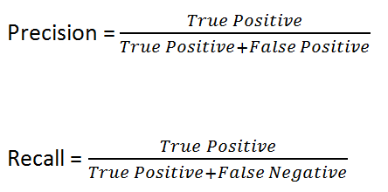

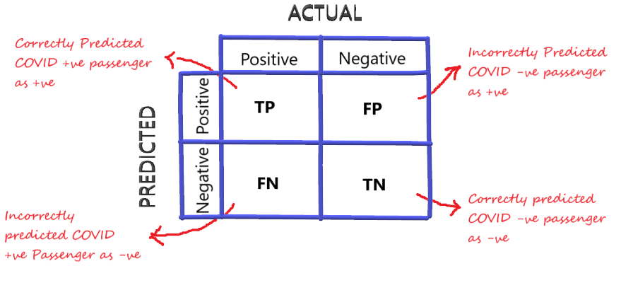

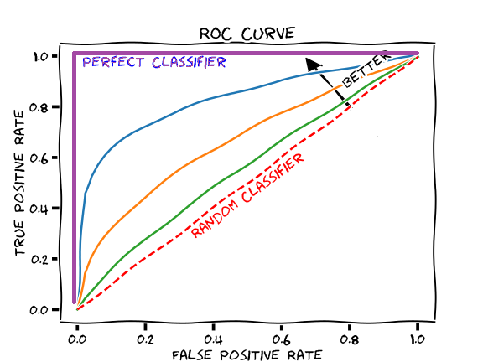

<https://developers.google.com/machine-learning/crash-course/classification/roc-and-auc>

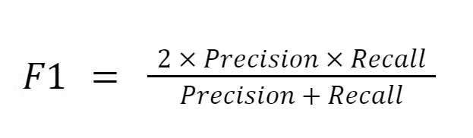

Top 5 classification metrics: <https://towardsdatascience.com/the-5-classification-evaluation-metrics-you-must-know-aa97784ff226>

### Clustering Metrics

We focus primarily on intrinsic measures because they don’t require ground truth labels. In a traditional clustering problem, we often don’t have access to the ground truth labels, and as such, extrinsic measures may not be possible.

**The Silhouette Coefficient** quantifies the cohesion and separation of clusters, offering a measure of how well-defined the clusters are. A higher Silhouette Coefficient indicates well-defined, separated clusters, while a lower value suggests overlapping or poorly separated clusters.

**The Davies-Bouldin Index** provides insights into the compactness and separation between clusters. A lower Davies-Bouldin Index indicates better clustering, with more compact and well-separated clusters.

**The Calinski-Harabasz Index,** or Variance Ratio Criterion, measures the sum of between-cluster dispersion against the sum of within-cluster dispersion, where dispersion is the sum of distance squared. A higher ratio signifies the cluster is far away from its other clusters and that the cluster is more well-defined.

These clustering metrics navigate the intricacies of unsupervised learning, where the absence of predefined labels demands a nuanced evaluation of how well algorithms group similar data points together. They serve as valuable tools in applications ranging from customer segmentation in marketing to image segmentation in computer vision.

7 types of clustering metrics: <https://towardsdatascience.com/7-evaluation-metrics-for-clustering-algorithms-bdc537ff54d2>

Paper explaining the formulas and differences between clustering algorithms: <https://citeseerx.ist.psu.edu/document?repid=rep1&type=pdf&doi=b2db00f73fc6b97ebe12e97cfdaefbb2fefc253b>

## Model Validation Techniques

As ML models traverse the dynamic landscape of data science, their prowess on training data is just the beginning. The true challenge lies in crafting models that can seamlessly extend their learning to uncharted territories, predicting and adapting to diverse scenarios with accuracy and reliability. Model validation, therefore, becomes an imperative step, acting as a litmus test for a model's ability to generalize its learning.

The validation process addresses the inherent risk of overfitting, a phenomenon where a model becomes excessively attuned to the idiosyncrasies of the training data, including its noise and outliers. Overfitting poses a significant challenge, as it can lead to poor performance when the model encounters new, unseen data. By subjecting models to rigorous validation, practitioners aim to mitigate this risk, fostering the development of algorithms that not only excel in controlled training environments but also gracefully handle the complexities of real-world applications.

### K-Fold Cross-Validation

One prominent technique that stands as a bulwark against overfitting is k-fold cross-validation. This robust method provides a systematic approach to evaluate how the results of a statistical analysis generalize to an independent dataset. The fundamental concept behind k-fold cross-validation involves the partitioning of the original dataset into k subsets, or folds.

The iterative process unfolds as follows: the ML model undergoes training k times, each iteration utilizing k-1 folds for training and the remaining fold for validation. This cyclical approach ensures that every data point has an opportunity to be part of both the training and validation sets, effectively mitigating biases associated with a specific subset of data. By averaging the performance metrics across these iterations, practitioners obtain a more comprehensive and reliable evaluation of the model's capabilities.

The benefits of k-fold cross-validation extend beyond its robustness in addressing overfitting. It provides insights into the model's stability and consistency across different data subsets, offering a more holistic view of its performance. Moreover, this technique is particularly advantageous when working with limited data, as it maximizes the utility of available information by systematically rotating through various subsets.

More Model Validation Techniques: <https://towardsdatascience.com/validating-your-machine-learning-model-25b4c8643fb7>

## Guarding Against Overfitting

The crux of k-fold cross-validation lies in its ability to guard against overfitting, a pitfall that can compromise a model's adaptability. Overfitting occurs when a model captures not just the underlying patterns in the data but also the noise and peculiarities specific to the training set. The consequence is a model that excels in replicating the intricacies of the training data but falters when faced with the variability inherent in new data.

By subjecting the model to multiple cycles of training and validation across different subsets, k-fold cross-validation acts as a vigilant overseer, identifying patterns that are consistently captured across various data partitions. This iterative dance ensures that the model generalizes well, making accurate predictions beyond the confines of the training data. The ability to adapt to diverse scenarios, a hallmark of robust ML models, is cultivated through this methodical and thorough validation process.

### 

### Beyond Robustness: Unveiling Additional Insights Through Cross-Validation

While robustness against overfitting is a primary objective of k-fold cross-validation, the technique unfolds an array of additional insights that enrich the understanding of an ML model's behavior. Stability assessment, for instance, becomes feasible by examining how the model's performance varies across different folds. Consistent performance across diverse subsets indicates a stable and reliable algorithm, instilling confidence in its real-world applicability.

Furthermore, k-fold cross-validation aids in identifying potential areas of improvement within the model. By analyzing performance variations across folds, practitioners gain valuable insights into aspects that may benefit from refinement. This iterative approach to model evaluation encourages a continuous feedback loop, fostering a culture of improvement and optimization in ML development.

Guarding Against Overfitting: Navigating the Perils of Overlearning in Machine Learning

In the intricate realm of machine learning (ML), the specter of overfitting stands as a formidable challenge, casting a shadow over the development of robust and adaptable models. Overfitting, a pitfall inherent in the learning process, unfolds when a model becomes too entangled with the intricacies of the training data, going beyond capturing underlying patterns and extending its grasp to the noise and outliers specific to that dataset. The perilous consequence is a model that showcases remarkable predictive prowess within the training data but stumbles when confronted with the nuances of new, unseen data.

### The Overfitting Conundrum: A Balancing Act

Overfitting can be likened to a musician memorizing a specific performance rather than mastering the art of playing music. In machine learning, it translates to a model memorizing the intricacies of the training data rather than discerning the broader patterns that enable adaptability to a variety of scenarios. The crux lies in striking a delicate equilibrium between learning from the training data and generalizing that knowledge to novel situations.

To navigate this conundrum, regularization emerges as a potent technique, serving as a guardian against the pitfalls of overfitting. Regularization operates on the principle of adding penalties to the loss function of the model, introducing a level of constraint to the model's parameters. By doing so, it discourages the model from fitting the training data too closely, fostering a balance between precision and adaptability.

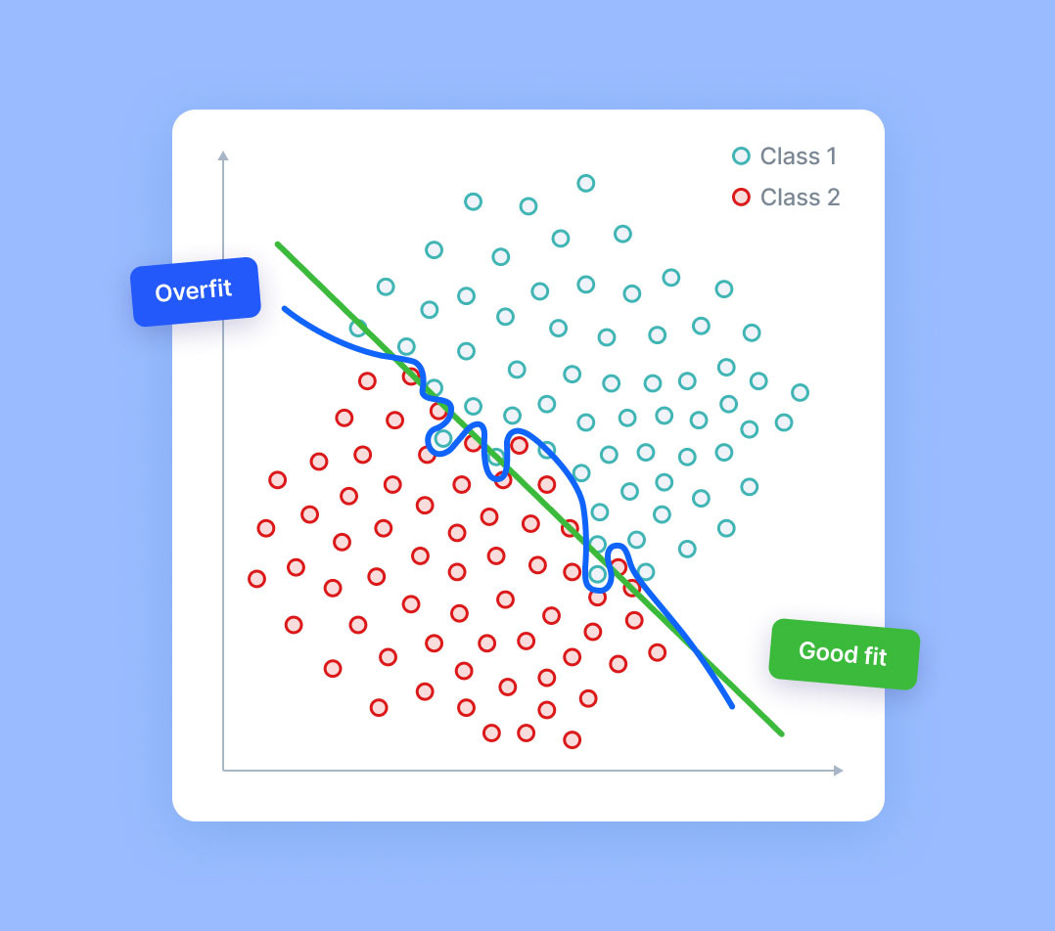

Ref: <https://www.v7labs.com/blog/overfitting>

### L1 Regularization (Lasso): Encouraging Sparsity for Simplicity

L1 regularization, colloquially known as Lasso, is a technique that introduces a penalty equivalent to the absolute value of the magnitude of coefficients. In essence, L1 regularization encourages sparsity in the model by pushing certain coefficients to precisely zero. This sparsity-inducing property is advantageous in scenarios where simplicity and interpretability are paramount.

Consider a scenario where numerous features contribute to the predictive power of a model, but not all are equally significant. L1 regularization, by zeroing out less impactful coefficients, simplifies the model, focusing on the most influential features. This not only aids in understanding the model's decision-making process but also acts as a preventive measure against overfitting to noise and outliers present in less relevant features.

### L2 Regularization (Ridge): Promoting Smaller, Non-Zero Coefficients

In contrast, L2 regularization, commonly referred to as Ridge regularization, takes a different approach by adding a penalty equivalent to the square of the magnitude of coefficients. This method promotes smaller but non-zero coefficients, preventing any one feature from dominating the model excessively. Ridge regularization is particularly effective in scenarios where multiple features contribute significantly to the overall predictive power, and a balance between these features is essential.

The essence of L2 regularization lies in tempering the influence of individual features, discouraging any single feature from overpowering the entire model. By promoting a more equitable distribution of coefficients, L2 regularization contributes to a model that generalizes well to diverse datasets, minimizing the risk of overfitting to idiosyncrasies within the training data.

[Regularization in a Neural Network | Dealing with overfitting](https://youtu.be/EehRcPo1M-Q?si=M2tN_cm2hF_kyMCe)

### Activity:

Play around with the different values for L1 and L2 regularization in the following playground: <https://developers.google.com/machine-learning/crash-course/regularization-for-simplicity/playground-exercise-examining-l2-regularization>. Observe how the network tends to under and overfit based on the values you tune.

### Regularization as a Guardian: Fostering Adaptability and Real-World Applicability

Regularization, in its dual forms of L1 and L2, assumes the role of a guardian in the realm of machine learning. Its overarching objective is to guide models away from the treacherous cliffs of overfitting, fostering adaptability and reliability in real-world scenarios. By introducing penalties that restrain the model's inclination to memorize the training data, regularization ensures that the model learns underlying patterns that transcend specific instances.

The delicate dance of regularization is akin to a mentor guiding a protege through the nuances of an art form. It imparts the essence of learning without fixating on specific instances, enabling the model to generalize its knowledge to novel situations.

Regularization, therefore, stands as a linchpin in the development of ML models, instilling in them the resilience and adaptability required to navigate the complexities of diverse datasets and unpredictable real-world scenarios.

Model Validation Techniques: <https://towardsdatascience.com/validating-your-machine-learning-model-25b4c8643fb7>

Model Overfitting Prevention Techniques: <https://towardsdatascience.com/8-simple-techniques-to-prevent-overfitting-4d443da2ef7d>

In-Class Activity:

* Model validation is similar between machine learning and deep learning architectures. Read through the following post including the comments: <https://www.linkedin.com/advice/1/how-do-you-test-validate-your-deep-learning-models>.
* Based on what you learned in class along with the resource included above, formulate a model validation checklist.
* There will possibly be a lot of terms and concepts you are unfamiliar with. Feel free to look them up and learn more.

## Conclusion

In this module, we have covered advanced concepts, evaluation metrics, and techniques essential for enhancing the robustness of Machine Learning (ML) models, marking a crucial phase where theory and practice converge. We explored comprehensive metrics for evaluating model performance across regression, classification, and clustering. In regression, we examined metrics like Mean Absolute Error (MAE), Mean Squared Error (MSE), and R-squared to assess prediction accuracy and model fit. For classification, we delved into metrics such as accuracy, precision, recall, F1-score, and the Area Under the Receiver Operating Characteristic Curve (AUC-ROC), which are crucial for models in scenarios with imbalanced datasets. In clustering, we explored the Silhouette Coefficient, Davies-Bouldin Index, and inertia to evaluate the effectiveness of unsupervised learning models in grouping data.

We also emphasized the importance of model validation techniques, particularly focusing on k-fold cross-validation, a robust method against overfitting that ensures model adaptability and consistency. Additionally, we addressed the challenge of overfitting in machine learning, exploring regularization techniques like L1 and L2, which add penalties to the loss function to prevent models from becoming overly complex and tailored to specific training data.